A Three-Hour Intensive Workshop

Learn a simple yet powerful technique to transform your thoughts that cause you suffering. Through a series of interactive exercises, video demonstrations and personal exploration, participants will use “The Work” to bring happiness and peace to their life. Based on the book, “Loving What is” by Byron Katie.
Cathy DeLauter participated in Byron Katie’s Residential 28-day program—“The Turnaround House”. In addition, she has participated in local seminars on “The Work” in East Lansing and in Warren, at Renaissance Unity.
She currently facilitates an on-going weekly Byron Katie Inquiry/Study group at the Interfaith Center for Spiritual Growth in Ann Arbor.

Cathy has been a teacher and student of metaphysics since 1978.
She is an ordained, non-denominational, Interfaith Minister from One Spirit Interfaith Seminary in NY. Her mission in life is to support others in fully remembering the “light” that they are, resulting in a more peaceful, joyous life.
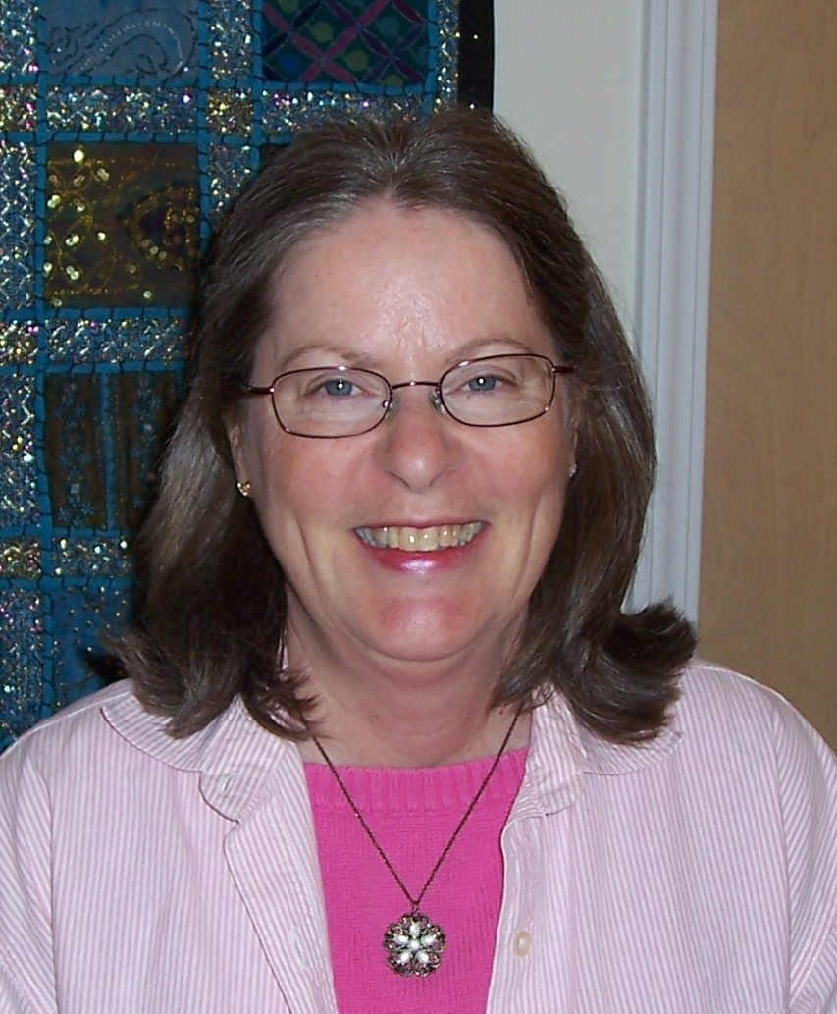
Saturday, January 16
9:30 a.m. – 12:30 p.m.
Registration begins at 9:15 a.m.
Class fee is $30.
for Location: please call Cathy at (734) 994-8847

What is “The Work”?
It is the application of 4 simple questions (& Turnaround) to a stressful thought.
Is it true? Can you absolutely know that it’s true? How do you react when you think that thought? Who would you be without that thought?
Here’s what Echkart Tolle author, The Power of Now & The New Earth has to say about “the Work”.
“Byron Katie’s Work is a great blessing for our planet. The root cause of suffering is identification with our thoughts, the ‘stories’ that are continuously running through our minds. The Work acts like a razor-sharp sword that cuts through that illusion and enables you to know for yourself the timeless essence of your being. Joy, peace, and love emanate from it as your natural state.”

For more information on The Work, please see http://www.thework.com or

Contact Rev. Cathy DeLauter at cdelauter@yahoo.com; (734) 994-8847
or visit http://www.cathy.delauter.com/

