A Three-Hour Workshop
(more in-depth & hands-on, application)
follows the A.M--Intro Seminar, I of The Work

Practice using the simple inquiry process of questioning stressful thoughts. This seminar is a continuation of interactive exercises and personal exploration based on the morning’s Introductory session. The class is designed to give participants more personal attention and experience in using “The Work”. Must either have attended the morning session or have prior experience using “The Work”.
Cathy DeLauter participated in Byron Katie’s Residential 28-day program—“The Turnaround House”. In addition, she has participated in local seminars on “The Work” in East Lansing and in Warren, at Renaissance Unity.
She currently facilitates an on-going weekly Byron Katie Inquiry/Study group at the Interfaith Center for Spiritual Growth in Ann Arbor.

Cathy has been a teacher and student of metaphysics since 1978.
She is an ordained, non-denominational, Interfaith Minister from One Spirit Interfaith Seminary in NY. Her mission in life is to support others in fully remembering the “light” that they are, resulting in a more peaceful, joyous life.
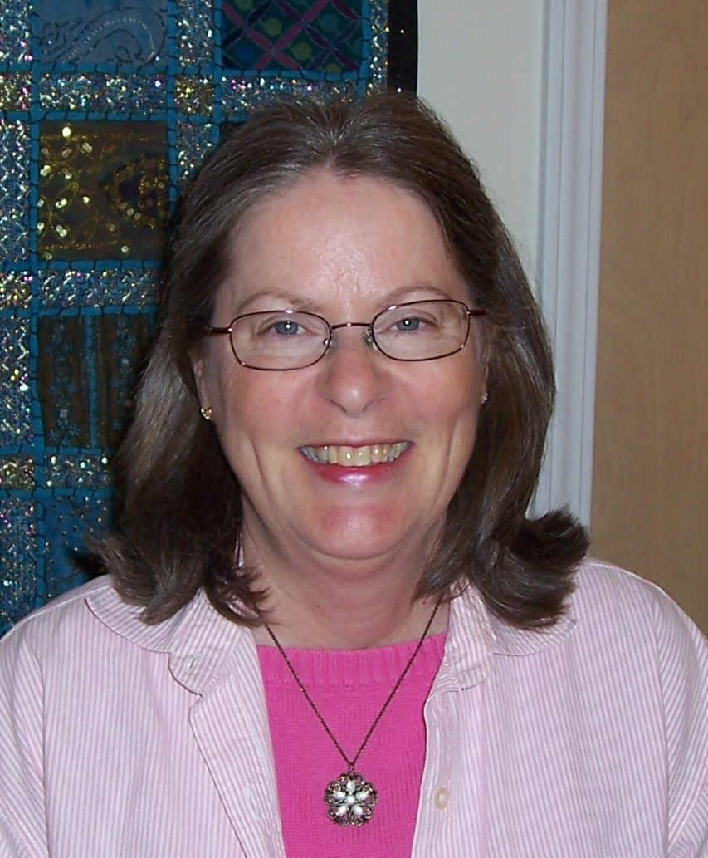
Saturday, January 16
1:30 p.m. – 4:30 p.m.
follows the morning Introduction Class
Class fee is $25.
for Location: please call Cathy at (734) 994-8847

What’s different about the afternoon session vs. the morning?
The afternoon session--is designed to give participants more hands-on; more experience using “the Work”. We will use several additional exercises to go deeper into the Inquiry process.

Here’s what Echkart Tolle author, The Power of Now & The New Earth has to say about “the Work”.
“Byron Katie’s Work is a great blessing for our planet. The root cause of suffering is identification with our thoughts, the ‘stories’ that are continuously running through our minds. The Work acts like a razor-sharp sword that cuts through that illusion and enables you to know for yourself the timeless essence of your being. Joy, peace, and love emanate from it as your natural state.”

For more information on The Work, please see http://www.thework.com or

Contact Rev. Cathy DeLauter at cdelauter@yahoo.com; (734) 994-8847
or visit http://www.cathy.delauter.com/

